Emergency planning advice for you and those you care for.

What will you do if it happens to you?

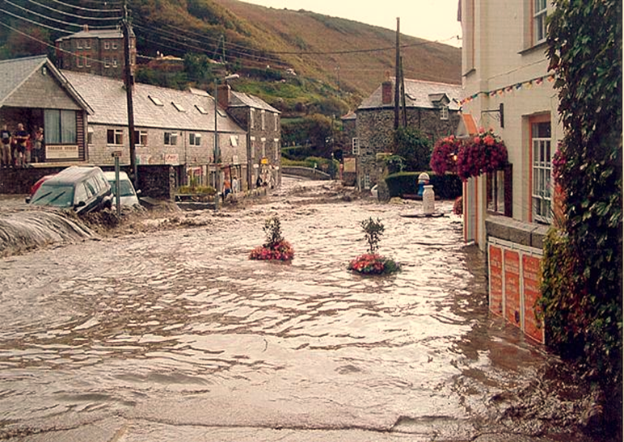

(Picture of a flood).

Events that could happen:

- Weather related (flooding, storms, heavy snow, heatwave).
- Public safety (fire, unexploded bomb, terrorism, explosion, chemical or nuclear leak).
- Disease (pandemic flu or animal disease).
- Major transport incident (road, rail, air, sea).
- Loss of essential services (electric, gas or water).

Please read and keep this information where you can find it.
If the unexpected happens

You will manage better if you are prepared and have a plan.

It does not require any special knowledge, only a few minutes of your time.

Talk to the people you live with about what you will do. You could write a home emergency plan.

Household emergency plan templates are often available on your council or local resilience forum website.
They can be used alongside the steps in this guide to help you prepare your plan.
There may also be community emergency plans already prepared in your area.
Contact your local town or parish council to find out whether there is one for your area and how it could help you.

Make your plan ‘clear’:

Check.
List.
Emergency Bag.
Act.
Recover.

Let’s take a closer look at this…

Check

Always check the radio, television, social media or internet for weather warnings and news.

Local radio and television news are usually reliable sources
of information. Find out which radio stations are the most
relevant and reliable for your area and set them as presets:

BBC Radio Devon | 94.8 | 95.7 | 95.8 | 96 | 103.4 | 104.3
BBC Radio Cornwall | 95.2 | 96 | 103.9
Atlantic FM | 105.1 | 107
Heart | 96.4 | 96.6 | 97 | 103
Pirate FM | 102.2 | 102.8
Radio Scilly | 107.9
Internet:

Reliable information is available online. Make these sources
your internet favourites. For example, www.metoffice.gov.uk,
www.environment-agency.gov.uk.

Social media:

Look for Twitter accounts providing information in your area which have been verified by Twitter. The information on these is more likely to be reliable as it comes from an official source. Good examples are the emergency services, your local council, the Met Office and the Environment Agency.

Look for facebook groups in your area. There may also be information here when the emergency is over and you are beginning to recover.
List

Make a list of any medication you take, important phone numbers and insurance policy numbers, and carry this at all times.

Keep important documents like birth certificates and passports above flood levels in a fire proof box.

Keep computer information on an external storage device.

You might also want to take all this with you, so keep them in one place or in an emergency bag.

Save useful numbers in your mobile phone and keep on a
list in your wallet or purse.

- For the emergency services, dial 999 (to Text 999, first register your phone at www.emergencysms.org.uk).

- Non-emergency Police enquiries, dial 101 (Text 67101, Textphone 18001 101).

- NHS Direct (medical advice), dial 0845 4647 (Textphone 0845 606 4647 or visit www.nhsdirect.nhs.uk).

- Environment Agency Floodline, dial 0845 988 1188 (Typetalk 0845 602 6340).

- Gas Leaks, dial 0800 111 999.

- Power Cuts, dial 0800 365 900 (Textphone 18001 0800 356 900).
- Water Leaks (non household), dial 0800 169 1144.

- Coastguard Information Line, dial 0870 600 6505.

- Highways Agency Information Line, dial 0300 123 5000.

Have you put ICE contacts in your mobile phone?

The emergency services are trained to check for the “ICE
number”.

Standing for “In Case of Emergency”, ICE allows the emergency services to contact someone if you are unable to do so. Think carefully about who you choose as an ICE contact because that person may need to give consent for medical treatment.

If you don’t carry a mobile phone or you keep it locked you can keep the same information on a card in a wallet or purse.

Emergency Bag

An Emergency Bag can be useful especially if you have to leave your home quickly or stay indoors without power for few days. It is easy to prepare one in advance.

The bag should be small enough to carry. You should check
the bag regularly to make sure it has everything you need
and that items like torches have batteries that work.

Your bag could contain:

- Copy of your household emergency plan if you have one.
- National Health Service numbers (ask your doctor’s surgery).
- Toiletries.
- First Aid Kit.
- Antibacterial hand gel.
- Wind up radio.
- Wind up torch.
- Spare batteries.
- Notebook and pen.

Don’t forget to take:

- Medication.
- Important documents.
- Essential keys.
- Items such as glasses for children and other people you care for.
- Mobile phone and charger.
- Items for pets.
- Cash/debit/credit cards.
Also, think about what you will need if you have to stay indoors
for a few days. Consider putting the following items in a separate box:

- Enough tinned or dried food and bottles of water to last three days.
- Candles and matches.
- Camping stove (only use indoors in an emergency. Place on a stable surface and use in a well ventilated area with a carbon monoxide detector).

Remember to check use by dates and regularly replace water.

Remember: if there is fire or another immediate danger in the house don’t stop to grab anything. Just get out.

Act

Should an emergency happen, act when you need to.

In an emergency, dial 999.
Do not put yourself or others at risk.
Follow the advice of the emergency services.

If the danger is outside – stay in:

Go In, Stay In, Tune In.

- Stay there until you are told that the emergency is over or you are advised to leave.
- Listen to local radio or TV news for updates.

If the danger is inside (or you are told to evacuate) – stay out:

Go Out, Stay Out.

If it is safe and you have time
- Take the items you need (including your emergency bag).
- Switch off power and lock doors and windows.
- Go to a safe place.

In the event of a flood:

Move valuable items to safety. If your house has property protection measures (such as flood gates or air brick covers) make sure you know how they work. Move pets to a safe place with plenty of food and water.
Stay safe when travelling:

In the case of severe weather listen to the advice of the emergency services and only travel if you need to.

Stay out of flood water whether in the car or on foot, you don’t know what’s beneath the surface.

Safe places:

Know the quickest and safest routes out of your house and have a safe place to meet if you get separated.

Safe places may be provided by the emergency services.

If you make your own arrangements, such as staying with friends, please tell somebody where you are.

Check if other people may need your help; information may not reach some as quickly.

Recover

Taking the ‘clear’ steps in this guide will help you recover and get back to normal much quicker.

After major incidents like flooding, there may also be recovery surgeries and drop ins which will provide you with further advice. Look out for information in the local media and from
your council.

If you found this leaflet useful, tell others and help them to
make a ‘clear’ plan:

Check information sources for weather warnings and news.
Make a List of important numbers and medication and carry this at all times.
Have an Emergency Bag ready.
Act when you need to.
Recover.

Space for making your own notes:

Your Local Resilience Forum (LRF)

This leaflet has been produced by the Devon, Cornwall and Isles of Scilly Local Resilience Forum (LRF). The Emergency Services, Local Government, Health Services and many other organisations work together to form the LRF.

The LRF has plans in place to respond to major emergencies, to save lives, contain danger, protect the public and to minimise the effects so we can all return to normality as soon as possible.

Everyone has a role to play in preparing for emergency situations. The LRF has produced this plan to help you develop a ‘clear’ plan of what you would do in an emergency. You can find more information on the website at www.dcisprepared.org.uk.

This leaflet has been produced by the Devon, Cornwall and Isles of Scilly Local Resilience Forum to provide general
information and advice about how to prepare for an emergency situation at home. It is not intended to provide detailed or
specific advice to individuals and as such the Forum or its constituent members will accept no liability arising from its use.

Plain large print version produced by Devon County Council.

