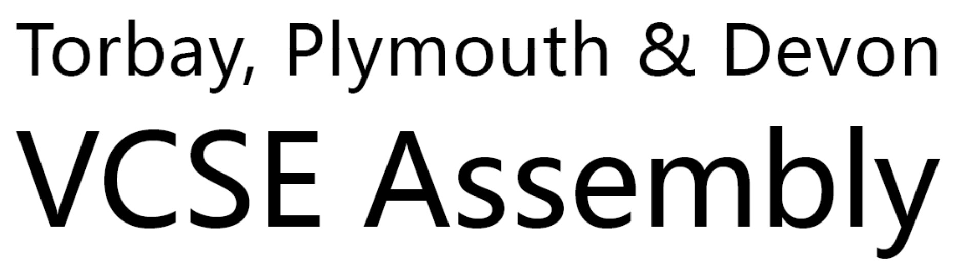
Minutes – 19/9/2025
- Welcome, Apologies, & Actions from Previous Meeting
The Chair welcomed attendees &noted that there were no outstanding actions from the previous meeting.
Combined Authority’s new governance structure & work programmes
The Combined authority has been on the cards for some time, there was a consultation in April 2024 and the submission in May 2024, the formal creation was on 5th February 2025. The CCA is one of only two non-mayoral CCAs in England (alongside Lancashire), placing it in a unique governance position. There are 5 Main Thematic Policy Areas of Responsibility
- Adult Skills & Lifelong Learning - £15M/year Adult Skills Fund to be devolved from Sept 2026 for post-19 education.
- Employment Support -Programmes like Connect to Work aim to support up to 1,900 people annually into employment across Devon, Plymouth & Torbay.
- Transport - Became Local Transport Authority upon creation; full powers commence April 2026. Responsibilities include transport planning, subsidised bus services, and infrastructure funding.
- Strategic Housing - Planning remains with local authorities, but CCA will lead on strategic housing and development strategy once legislation passes (expected Christmas 2025).
- Economic Development & Inward Investment -Functions from the former Local Enterprise Partnership now sit with the CCA. Local Growth Plan (approved July) highlights strong post-pandemic economic performance.
The governance structure sits as:
- Constituent Members: Devon County Council & Torbay Council (3 members each)
- Non-Constituent Members: Devon districts, Police & Crime Commissioner
- Associate Members: Advisory groups (business, skills, housing, transport, climate, investment)
- Committees: Overview & Scrutiny, Audit & Governance, Standards
- Advisory Groups: Provide subject matter expertise; non-decision-making
Current Key Programmes and Priorities
- Adult Skills Fund: Launch planned for Sept 2026; focus on tailored local provision.
- Connect to Work: DWP-backed employment programme launching in 3 weeks.
- Transport Planning: Work underway to define operating model for April 2026 transition.
- Housing & Spatial Planning: Awaiting legislation to formalise strategic planning role.
- Funding Advocacy: Representations to government on:
- Budget allocations (especially for non-mayoral areas)
- Successor to UK Shared Prosperity & Rural England Funds (ending April 2026)
- Sustainability of Further Education sector

Look back at the Belong in Plymouth initiative
POP was commissioned by the National Lottery as part of the Healthy Communities TOGETHER programme, one of five sites nationally. The aim was to improve partnership working between VCSE, statutory, and health organisations, with a focus on grassroots engagement in Plymouth. POP emphasises connecting and amplifying community voices, fostering person-to-person relationships, and bringing together different sectors to find shared solutions. There were 3 key projects:
Belong in Plymouth:
- Focused on social isolation and loneliness.
- Recruited and trained 118 community researchers post-pandemic.
- Researchers conducted and recorded conversations, resulting in 890 qualitative fragments.
- Used AI to analyse and map themes of belonging, leading to sector-wide discussions and a physical “map of belonging.”
Neighbourhood Work:
- Ran a 14-week course with local residents (many with lived experience of isolation or deprivation).
- Outcomes included a community magazine (now in its third edition), drop-in sessions, and outreach in local parks.
- Participants moved from being service users to service providers.
Youth Engagement:
- Young people trained as community researchers, conducted peer conversations, and created a documentary on youth life in Plymouth.
- Documentary used to engage city leaders and presented to MPs in Westminster.
The legacy comes in the form, of a legacy website hosting resources, including the youth documentary and a searchable conversation tool for qualitative research on social isolation and belonging. Alongside Initiatives such as “Health is Wealth” brought health services into deprived areas. Lastly ongoing collaborative networks between health researchers, VCSE, and community members.

Q - who the collaborators were on that project
A - it started off between community empowerment in Plymouth City Council and pop.
We then used a wide approach to try and entice people into it and what we ended up with was a network of about 250 people on a platform called groups IO. People had some freedom to come and go. Although key people stayed with the whole time -
University Hospitals Plymouth, a black LED organisation called Diversity Business Incubator, The City Council, particularly the community empowerment side of that, the community builders in Plymouth.

Q - did you get any difference from depending on which communities you're engaging with?
A - No, we kept the the demographic data light deliberately, but we are able to trace each fragment to an actual conversation with an actual person, so we can pull demographics into it. I think what we find was that, it's a psychological position. Loneliness, although some people might have easier access to transport than others, very often it's events that that cause people to become lonely. It might be that you are a leader, reasonably affluent time in Plymstock, but then all of a sudden you're not able to drive because of health or infirmity or old age and then transport becomes a huge issue, whereas in fact it didn't used to be. What we developed was an embedded feeling within people and how they felt towards belonging in Plymouth and so no and that was not profoundly different across poverty or like age or some of the expected places you might feel.

Q - I kind of wonder in your research how much the engagement with the people who by their own definition are saying they felt lonely and isolated, related how much the actual work that you were doing in terms of some of the group activities and some of the stuff actually helped to address the underpinning issue. So how much the research in effect was actually also supporting those people also with the data that you've provided or that you've got now available, which is amazing, how topical does it remain? I mean, you know, you did it over three years, is it still going to be relevant in five years, two years, 10 years, 15 years? What's your sense of those two things?
A - I don't know in terms of how relevant the data will say, some of the comments are quite specific. So for example, the trees was a big huge thing in Plymouth around that time. There are some references to trees which will probably not stay the same in five or ten years time as people forget things. I think the process is very relevant and I think there's a way that the process could be repeated in different areas around different things. I think it's quite interesting. I feel like there's the beginning of understanding of new ways of engagement rather than your standard survey that goes out and you get 6 or 7% of a population that might like reply there seems to be different ways of creating engagement which the process of doing that actually activates people to become better citizens and in a sense, somebody new to Plymouth didn't know anybody felt very isolated, were incapacitated due to kind of quite severe in health and then have kind of gradually moved from somebody who whose story was told through becoming a community researcher through getting more involved in the programme through becoming part of the core team to now becoming really well established within lots of different activities within the city, so it feels like the tools we use can support the processes and the outcomes that we want to have.

AOB
In November, Nutriri has been selected to present a problem summary and lead a roundtable at the BMJ Future Health Conference, and we’d like your input - here's the Problem Summary: Only 10% of eligible people attend Diabetes Structured Education, in some areas only 10% take up NHS Health Checks; consider these poor engagement figures against the 2% of weight management referrals who report 5% weight loss. (National Diabetes Audit, OHID, Fingertips Data) - Nutriri believes that weight centric policy discourages engagement and that weight neutral/inclusive services will rebuild trust, reduce disparities and achieve better health outcomes. Our first call to action is to ask VCSE spaces - what else is impacting such low engagement rates? Feel free to email helen@nutriri.org cc. heathereggins@nutriri.org and we’ll include it in the roundtable in November.

