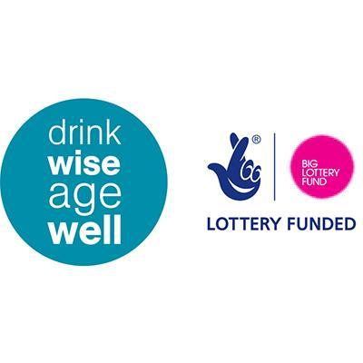
LIVE WISE AGE WELL
Free 6 Week Well Being Course for the
Over 50’s
Session 1. Age Well: Adjusting to changes as we age - We talk about what it means to be getting older – challenges, opportunities, advantages and disadvantages. We discuss the life stages. Is being older better or worse, how and why? Our aim is to encourage people to be positive about ageing, and to challenge the negative messages spread by society.
Session 2. Feel Well: Maintain a healthier you – We discuss food, sleep, hydration, and relaxation. We introduce the idea all of these factors, in more or less equal measure, are vital to physical and mental well-being and, thus, aging healthily. We may also discuss money matters because money, matters.
Session 3. Think Well: Maintaining a healthier mind – We investigate, using Cognitive Behavioral Techniques (CBT), the way we think and how we can develop ways to create more balanced thinking styles. We introduce the concept of Mindfulness and its practice.
Session 4. Plan Well: Having goals and keeping active – We discuss values - what is personally meaningful and gives life purpose. We talk about how those values may change over time and how they may differ from one person to another. We examine the value of staying fit and active through regular exercise and how it may help maintain quality of life.
Session 5. Connect Well: Circles of support and Communication – We map social networks in the locality, each person contributing from their personal knowledge base. We map individual support networks and discuss how they may be expanded. We explore the art of communicating effectively to aid the building of successful relationships.
Session 6. Live Well: Travelling forward – We discuss strategies to manage worry, and introduce problem solving techniques. We have a revision and recap of the course, revisit learning points, goals set and future plans.

