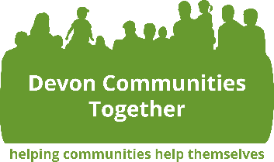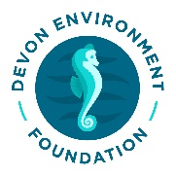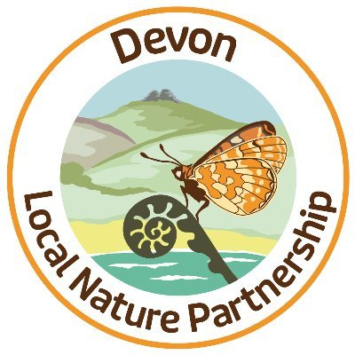

Wild About Devon – Community Wildlife Fund
Guidelines

Grant Scheme to help communities across Devon to take action for wildlife as part of the Local Nature Partnership’s Wild About Devon initiative and the urgent need to tackle the Ecological Emergency.
Purpose of fund and criteria
DCT is happy to announce the relaunch of the Wild About Devon – Community Wildlife Grant Scheme. This fund is financed by the Devon Environment Foundation (DEF), Devon Communities Together (DCT), and Devon County Council (DCC), as part of the commitment to help tackle the Ecological Emergency.

Whilst Devon is green and superficially beautiful, we have lost vast areas of habitat and species over the last 50+ years. Community action can make a huge difference to tackle the ecological emergency through changing the management of gardens, parks, green spaces, churchyards, orchards, window boxes, ponds and ditches and buildings in a way which will benefit wildlife.

The aim of the grant scheme is to provide a very simple way for community groups to access small amounts of funding to kickstart or advance their group / activities. It may also be used to support the acquisition of much needed advice, equipment, and other resources.

Eligibility Criteria
The funding is open to any community action for wildlife in Devon (including Torbay, but excluding Plymouth). All types of community groups with a wildlife focus or wildlife project they want to undertake can apply for this grant. This includes but is not limited to:

- Community wildlife groups
- Town / Parish councils
- Schools and Multi-Academy Trust (MATs)
- Collaborative partnership among groups to maximise impact are allowed, however the application will have to be made by a lead partner.

Please note that only not for profit groups and organisations are eligible.

What will be funded
The applicant must submit a clear and realistic proposal of how the funds will support a particular project or initiative idea that:
- Is focussed around improving a local area for wildlife that will provide long term benefits
- Has clear community involvement and may inspire other communities to do similar projects.

We will prioritise projects that support important landscapes such as species-rich grassland.

Funds can be used for a wide range of activities or equipment.. Some examples of things we will support are:
- The purchase of tools and equipment, including for monitoring species
- Training,
- Consultancy,
- Management work etc.
- Wildlife pond creation

Some things that we would not support include:
- Tree planting, as there are other sources of funding available for this
- Planting of annuals or other schemes that do not have a long term benefit
- Unfortunately we are unable to support projects in Plymouth

Terms of Funding
- You can apply for grants of up to £500. We however encourage more applications for smaller amounts of around £100 or less so we can help more communities.
- Please include cost breakdown, and make sure all estimates / quotes are included.
- Payments will be made by bank transfer to the account details provided. DCT is unable to transfer funds directly to a contractor or service provider. You can provide bank details of a host in your application if your group does not have a bank account.

It should also be noted that the applicants remain responsible for all aspects of the work and DCT or the Devon Environment Foundation will not intervene in disputes between applicants and suppliers and contractors. DCT and the funding partners will not be liable for any damages, financial loss, etc. resulting from the group or parish and town councils’ activities.

- All successful candidates will be required to make a formal agreement with Devon Communities Together which includes:
- Providing progress updates; case studies/video evidence of the project within 6 months of receiving funds.
- Join our county wide peer support network to have access to varied peer support, opportunities, resources, etc. Click on this link to join our Wild About Devon - Community Action for Wildlife Devon Facebook group.
- Participation in at least one WAD focus group to share information and learning and explore the potential to develop our county wide peer support network.

How can you apply?
Interested applicants that fit the above outlined criteria should kindly apply by clicking on the link below. https://forms.office.com/e/06SvQWZPDj
For further information about this grant scheme, kindly contact Natalie Campbell (natalie.campbell@devoncommunities.org.uk) or call 01392 248919
The fund will be administered on a rolling basis, however, due to the limited amount of funding, we encourage potential applicants to submit their proposals in due time.

Next Steps
- You should allow up to a month to receive feedback on your application.
- You will receive a confirmation email with further information if your application is successful.

