A Guide to Working with Autistic Individuals
We’ve used the term “autistic” here as the term which seems to be preferred by most autistic people, although we recognise that there is still some disagreement. Other people prefer the term “on the autism spectrum” and some prefer person-first language such as “person with autism”. For an excellent comic showing autism as a spectrum see: https://www.dropbox.com/s/aaz1h8b83qt46zz/thespectrum.pdf?dl=0

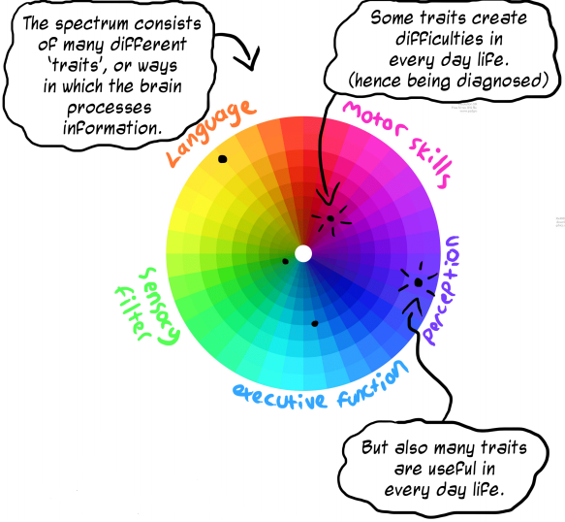
All people with autism are individuals, just as any non-neurotypical individual will be. Autistic people will have completely different experiences and issues, with a huge range of strengths and challenges. Therefore, there is no general advice that can be applied when working with people with Autistic Spectrum Condition. However, there are considerations that can be made and discussions that should be had, prior to engaging regularly, to inform your practice. For example, some individuals may struggle with…P.T.O

Being hyper-sensitive to light, noise, smells and textures; | Lack of cognitive functioning;
Obsessive behaviours; | Irregular meetings;
An inability to picture a future event or scenario; | Have specific interests which overrule focus;
Taking things literally or not understanding humour; | Understanding the irrationality of some social constructs;
Becoming easily overwhelmed; | Focusing on more than one thing;
Instructions that are vague or open-ended.

Must do strategies:
The following are especially important If engaging with individuals beyond their usual settings, without familiar faces or routines. First, clearly explain who you are, outline any potential triggers which may happen through the day – such as loud noises or bright lights – so that individuals can prepare themselves in advance. Be clear at the beginning that there is space for individuals to withdraw if they are overwhelmed or angry. Don’t pressurise them into a decision straight away: you may lose them before you’ve even started! Being triggered at an event may stop them from trying more new things and they may withdraw. Relish the small victories.
Some further strategies:
- Try not to overload with too much information, or ask questions that need multiple answers (such as you may get at job interviews!). They might focus on answering one part of the question but be overwhelmed if more than one answer is required.

- Be literal and specific in your instructions. Sometimes sarcasm/irony does not translate and can be confusing. Linear and clear speaking will often translate better. Clarify if something is a joke, as the person may feel confused and this could lead to a meltdown.

- Anxiety can sometimes increase if the individual cannot picture a future event. Therefore try taking a stepped approach, detailing important stages building up to an event such as how they get there, what to expect, what may be expected of them and how they can leave if they become uncomfortable and reassure them that this is fully OK!

- Don’t be shocked if someone with ASC is brutally honest, or tells you how they see it.

- Other social norms may also be ignored, especially if the participant cannot rationalize these / see the relevance. Make allowances for behaviours that seem unusual but aren’t harmful to you, the Autistic person, or people around them.

